**Requirements Validation**

**Date: 2017 09 26**

**Project Name:**

Automatic Playlist Recommendation System

**Project Members:**

Indrajeet Mishra, Priyanka Sharma, Sairam Rajagopalan, Dhiksha Ramkumar, Elizabeth Thomas

**Discussion (Issues and Resolution):**

1. If we recommend songs based on user history, what will we recommend for new users?
2. Should the system include some type of administrative GUI where an admin can add or remove songs?
3. Should we add any other features besides song recommendation?
4. How will we manage security issues for user data?

All queries have been posted in trello list Q/A. Instant emails are sent to team and issues are resolved.

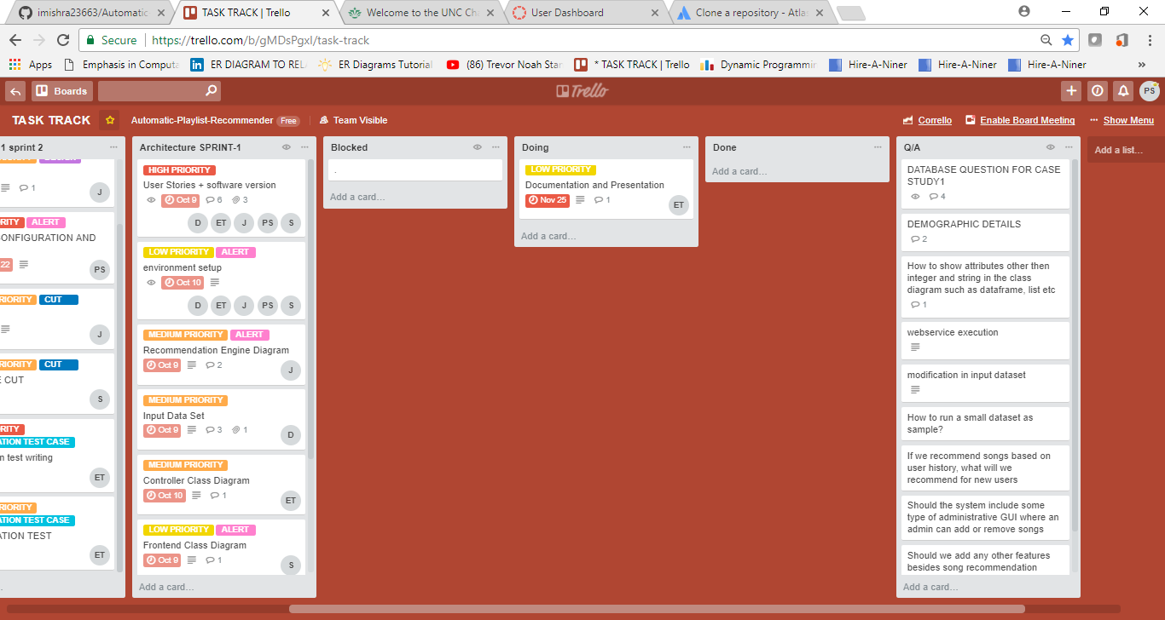

**Scenarios:**

1. User who has a listening history with the system will log in and receive a list of recommendations based on his or her listening history.
2. Admin will log in and be able to manage the song database.
3. New user will register and then be able to log in.
4. A user will log in and subscribe to an artist and receive song recommendations based on that artist.

**System Participants:**

Potential participants include fitness instructors, teachers, therapists, and anyone who enjoys listening and discovering new music.

**Customer Requirements:**

If this were a project being commissioned by a client, we could assume that our customers would desire the project to be completed using the most efficient time and resources possible. The customers would also desire that the system provide recommendations quickly and accessibly for users.

**Functional Requirements:**

The system shall provide recommendations that are relevant to the user, based on that users’ history (or if the user has no history, based on popularity). The system shall recommend songs by a specific artist to users who have followed an artist. The system shall allow an administrator to access and update the database.

**Non-Functional Requirements:**

The system must protect user data security. The system GUI must be easy to use and have a high level of availability. The system shall not take more than 5 minutes to recommend songs to a user.

**Preliminary Diagrams:**

See preliminary diagram document.